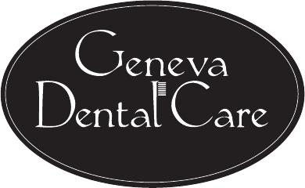
Our Recommended Clinical Standard of Care for Our Patients**
1. CLEANINGS AND EXAMS:
A: How often?: We recommend patients with healthy gums have preventive cleanings every six months. We recommend patients with a history of periodontal disease or heavy tartar accumulation have a cleaning every 3-4 months on a case-by-case basis.
B. Why?: Dental cleanings are important to help remove plaque and calculus below the gumline that contributes to caries and periodontal disease. It is important to note that oral health is an important factor in OVERALL health, and several other medical conditions are linked to the mouth.
C. Recommended age: We typically begin seeing patients in our office for cleanings beginning at age 3.
2. FMX (Full mouth x-ray) or PANORAMIC RADIOGRAPHS
A: How often?: Every 3 – 5 years
B. Why?: To detect cavities along with pathology BELOW the gumline. In some cases, a clinician may recommend both an FMX and a panoramic x-ray in order to make a thorough diagnosis.
C. Recommended age: We may recommend panoramic radiographs at an early age to help determine if a patient needs orthodontic intervention. Panoramic radiographs are also made to help evaluate the presence of wisdom teeth in teenagers and adults. We typically begin making full mouth series of radiographs around age 18 and then every 3-5 years.
3. ANNUAL POSTERIOR BITEWING AND ANTERIOR PERIAPICAL
A: How often?: We alternate 4 bitewing (back teeth) radiographs and 3 periapical (front teeth) radiographs every six months for adults. For children we typically make 2 bitewing and 2 periapical radiographs every year. We may recommend radiographs more frequently in patients with increased risk of tooth decay.
B. Why?: To detect cavities between the teeth that may be difficult to see with the naked eye; this allows us to detect a cavity in its early stages, helping you to avoid costly treatment in the future.
C. Recommended age: We will begin making some radiographs as early as age 3 or 4.
4. FLUORIDE VARNISH EVERY 6 MONTHS
A: How often?: Every 6 months
B. Why?: To prevent future cavities and manage sensitivity.
C. Recommended age: After first tooth has erupted
5. ANNUAL VELSCOPE ORAL CANCER SCREENING
A: How often?: Once per year
B. Why?: To help detect abnormal soft tissue pathology which could be oral cancer.
C. Recommended age: Age 18+

**ALTHOUGH THESE ARE OUR GENERAL GUIDELINES, ALL TREATMENT IS RECOMMENDED ON A CASE-BY-CASE BASIS TO INDIVIDUALLY ADDRESS A PATIENT’S SPECIFIC NEEDS

**YOUR PREVENTATIVE COVERAGE MAY NOT COVER ALL OF OUR RECOMMENDED STANDARD OF CARE TREATMENT. Please learn your policy; we will help you as best we can with our complimentary breakdown of benefits, but it will greatly benefit you to know your own policy to avoid confusion.

